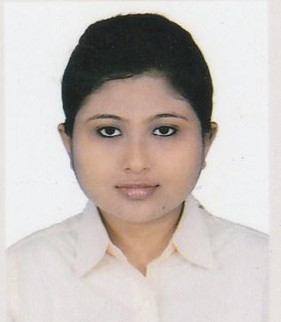**JHILIK MITRA**

2 No. Debigarh (3rd Lane), Madhyamgram,

North 24 Paraganas, Kolkata-700129.

Ph. - +91**- 9038220852** | email: [**jhilik.mitra1995**@gmail.com](mailto:jhilik.mitra1995@gmail.com)

**CAREER OBJECTIVE**

To be a part of a reputed organization and contribute towards its growth and success using my potential skill set to the maximum.

**EDUCATIONAL QUALIFICATION**

|  |  |  |  |  |
| --- | --- | --- | --- | --- |
| EXAMINATION | SCHOOL / COLLEGE | BOARD | YEAR | MARKs |
| B.Tech (IT) | B.P.Poddar Institute Of Management & Technology | MAKAUT-WB | 2019 | 8.66(sem 6 ) |
| AISSCE (XII) | R K S Vidya Mandir | CBSE | 2014 | 95 |
| AISSE (X) | R K S Vidya Mandir | CBSE | 2012 | 10 CGPA |

**SUBJECTS OF INTEREST :**  C, Java, Database Management System.

**TRAINING AND PROJECT UNDERTAKEN**

|  |  |  |
| --- | --- | --- |
| **INSTITUTE NAME** | **TOPIC** | **DURATION** |
| National Institute for Industrial Training | **Web Development**  & Project on **Hotel Management System** | 1 Month |
| B.P.Poddar Institute Of Management & Technology | **Book Store Management System** | 15 days |

**CERTIFICATION**

* **NPTEL Online Certification** funded by the Ministry of HRD, Govt. of India and certified by IIT Kharagpur for **Problem Solving Through Programming in C** in 2018 .
* **C Training & JAVA Training** offered by **Spoken Tutorial Project, IIT Bombay**, funded by National Mission on Education through ICT, MHRD, Govt. of India in 2017 .

**EXTRA CURRICULAR ACTIVITIES**

|  |  |  |
| --- | --- | --- |
|  | Participated in the inter-college event **Fanta- C** at **Techstorm 2.16.**  Participated in the inter-college event **Omegatrix at Techstorm 2.16**  Participated and 1st Runners Up respectively in the inter-college event **Treasure Hunt at Panache 2.15 and 2.16**  Painting ( Passed 6th year exam from Bangiya Sangeet Parishad )  Dancing (Certificates in performing various solo and group dance ) |  |

**PERSONAL DETAILS**

**Date Of Birth :** 29th September, 1995.

**Hobbies :** Reading Story Books, Painting.

**Languages :** Bengali , English , Hindi .

**DECLARATION**

***I do hereby declare that the above given statements are true and correct to the best of my knowledge.***

Date : Signature

  Place : Kolkata -------------------------------------

 (Jhilik Mitra)

|  |  |  |
| --- | --- | --- |
|  |  |  |
|  |  |  |